Lakes:

Kachura Lake

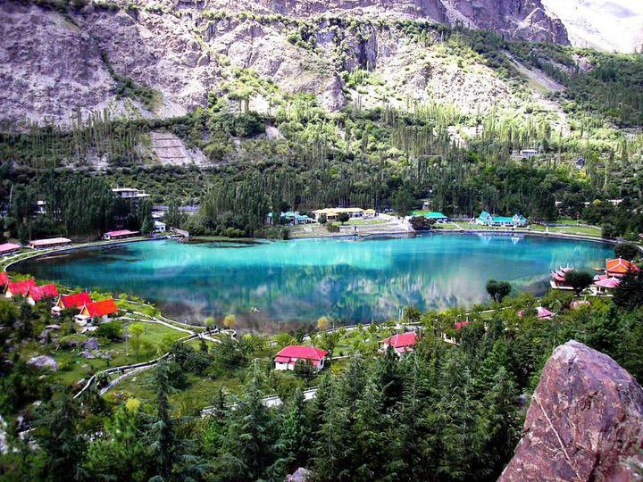

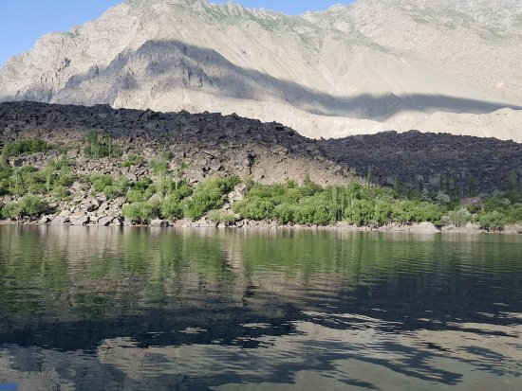

The **Kachura Lakes** are two lakes in the Skardu District of Gilgit-Baltistan, northern Pakistan. The lakes, at 2,500 metres (8,200ft) in elevation, are **Upper Kachura Lake** and **Lower Kachura Lake**. The latter is also known as Shangrila Lake and is within a tourist resort named Shangrila Resort outside the town of Skardu. The lakes are in the Karakoram mountain range of the western Himalayas, the greater Kashmir region, and in the Indus River basin.

Attabad Lake

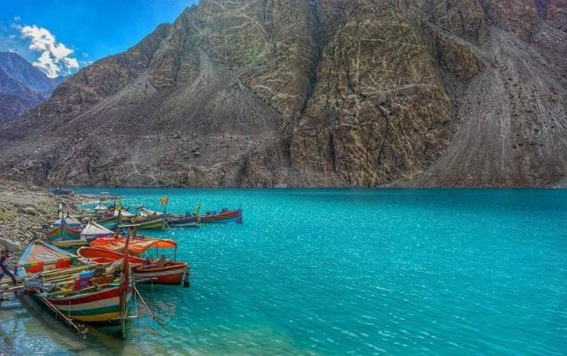

**Attabad Lake** is a lake in Gojal Valley, Hunza, Gilgit Baltistan, an administrative region of Pakistan. The lake was created in January 2010 as a result of the Attabad Disaster. Attabad Lake has become one of the biggest tourist attractions in Gilgit-Baltistan offering activities like boating, jet skiing, fishing and other recreational activities. The lake was formed due to a massive landslide at Attabad Village in Hunza Valley in Gilgit-Baltistan, 14 kilometres (9 mi) upstream (east) of Karimabad that occurred on 4 January 2010. The landslide killed twenty people and blocked the flow of the Hunza River for five months. The lake flooding has displaced 6,000 people from upstream villages, stranded (from land transportation routes) a further 25,000, and inundated over 19 kilometres (12 mi) of the Karakoram Highway .The lake reached 21 kilometres (13 mi) long and over 100 metres (330 ft) in depth by the first week of June 2010 when it began flowing over the landslide dam, completely submerging lower Shishkat and partly flooding Gulmit.

Rawal Lake

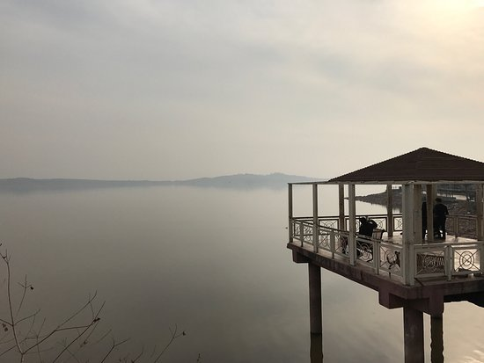

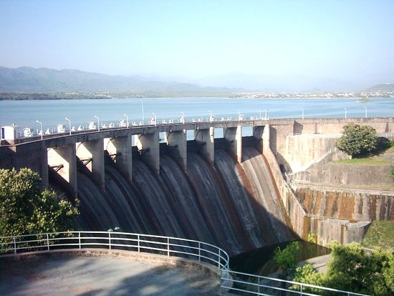

**Rawal Lake** in Pakistan is an artificial reservoir that provides the water needs for the cities of Rawalpindi and Islamabad. Korang River along with some other small streams coming from Margalla Hills have been set to form this artificial lake which covers an area of 8.8km². Korang River is the outlet stream of Rawal Dam. Rawal Lake is located within an isolated section of the Village Malpur, Bani Gala and Margalla Hills National Park. The area around the lake has been planted with flowering trees and laid out with gardens, picnic spots, and secluded paths. The terraced garden and the lake are used for picnics, fishing and boating. The highest point in the garden offers a panoramic view of the lake, Margalla and Murree hills, Rawalpindi and Islamabad.

Keenjhar Lake

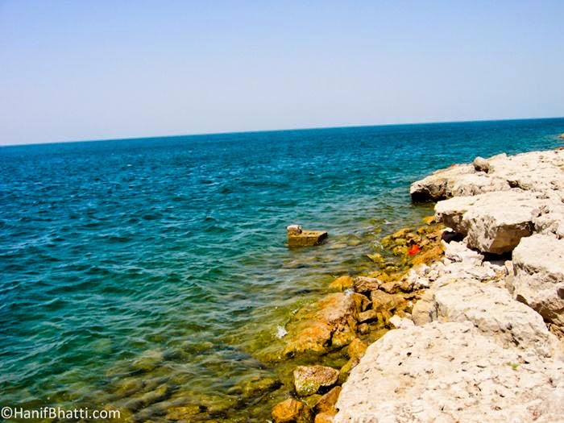

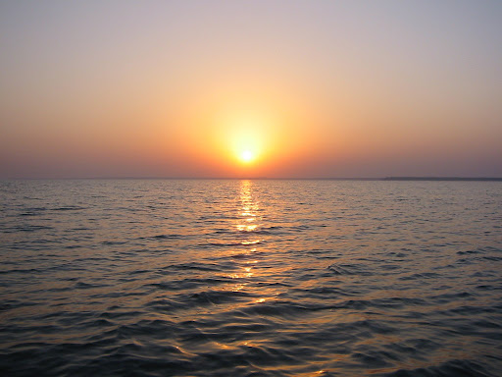

**Keenjhar Lake** is in Thatta District, Pakistan. It is 122km from Karachi and 18km from the town of Thatta. It is the second largest fresh water lake in Pakistan. It is an important source of drinking water for Thatta District and Karachi city. Keenjhar Lake has been declared a ramsar site and a wildlife sanctuary. It provides a favorable habitat of winter migratory birds like ducks, geese, flamingos, cormorants, waders, herons, egrets, ibises, terns, coots and gulls. It has been observed as a breeding area of the black-crowned night heron, the cotton pygmy goose, purple swamphen, and pheasant-tailed jacana.

Banjosa Lake

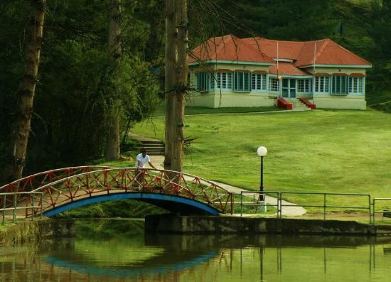

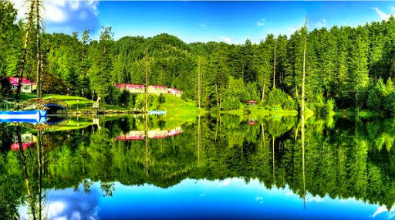

**Banjosa Lake** is an artificial lake and a tourist resort 18 kilometers (11mi) from the city of Rawalakot in Poonch District of Azad Kashmir, Pakistan. It is located at an altitude of 1,981 meters (6,499ft). The lake is surrounded by dense pine forest and mountains, which make it charming and romantic.The Lake is accessible by a metallic road from Rawalakot. The weather in the area remains cool in Summers and cold in Winter. In December and January snowfall also occurs here and the temperature falls to -5 °C. During Summer, the temperature remains 16 °C (61 °F) to 25 °C (77 °F). Some rest houses and huts of AJK Tourism and Archeology Department, Pakistan Public Works Department and Pearl Development Authority are located here.

Hanna Lake

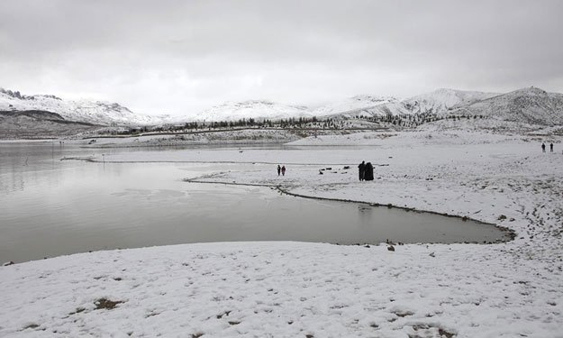

**Hanna Lake** is a lake in Urak Valley near Quetta city in Balochistan Province in southwestern Pakistan. It is surrounded by mountains. Hanna Lake is in the hills close to where the Urak Valley begins 17 kilometres (11 mi) east from Quetta city. The reservoir was constructed in 1894 during the British Colonial era on the land of local tribesmen, and is one of the main attractions in the city and a great historical bridge wall between two mountains the depths like battlements of a fort for storing of water. There is a lakeside restaurant with picnic tables shaded by pine trees at the end of the river where families can enjoy the food and weather on the eastern part the Hayat Durrani Water Sports Academy (HDWSA) the first and only rowing, canoeing, kayaking and sailing training and championships organising centre in Balochistan Province with provision of rough swimming facility. Hanna Lake is one of the most visited and accessible lakes in Balochistan.